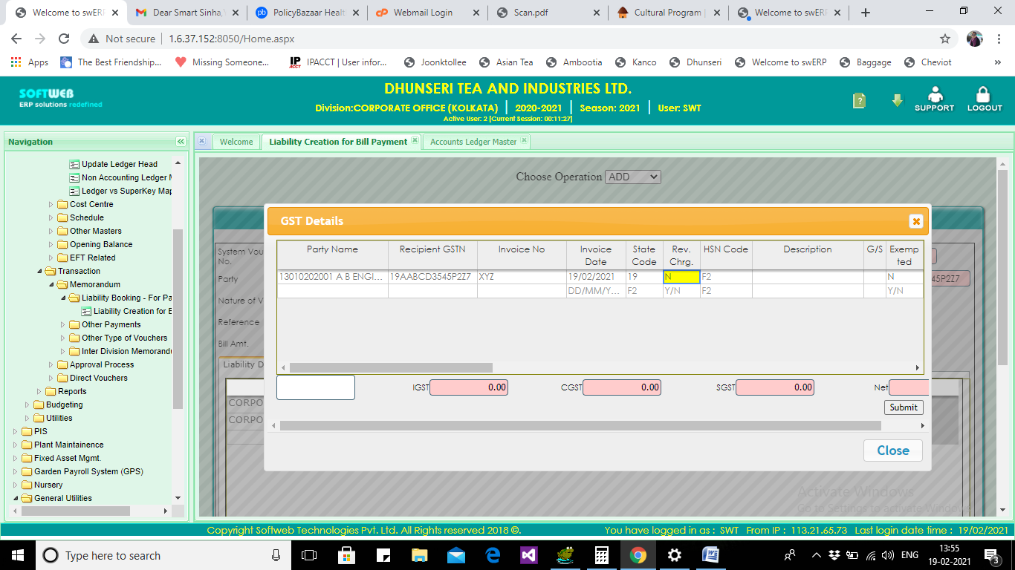

Task 1:

~~HSN Code Position Change after state code~~

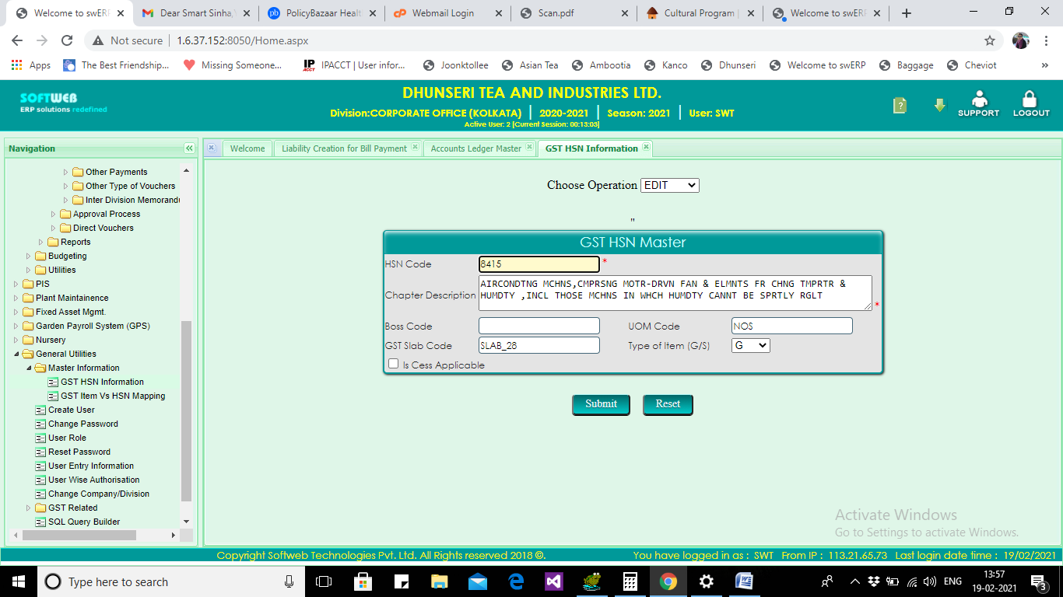

Task 2:

~~Add Input Credit as check box (Y/N)~~

~~Reverse Charge check box (Y/N)~~

~~GST Applicable check box (Y/N)~~

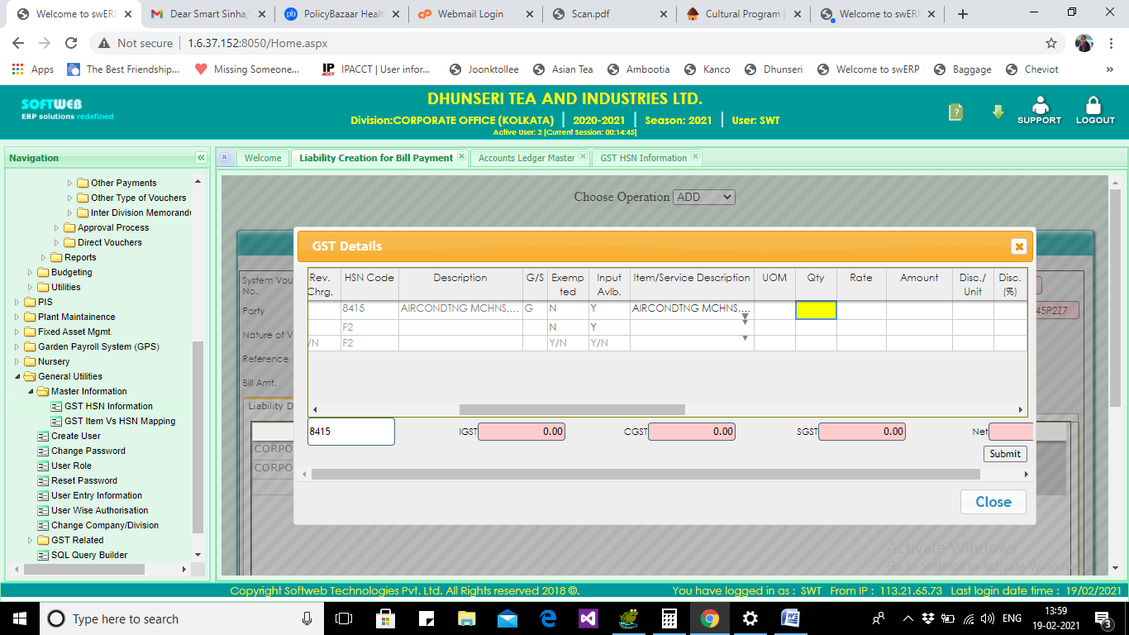

Task 3:

~~In case of service allow quantity null or zero(0).~~

~~If qty = null then Amount = Rate~~

After selecting HSN Code, clear previous values after HSN in same row

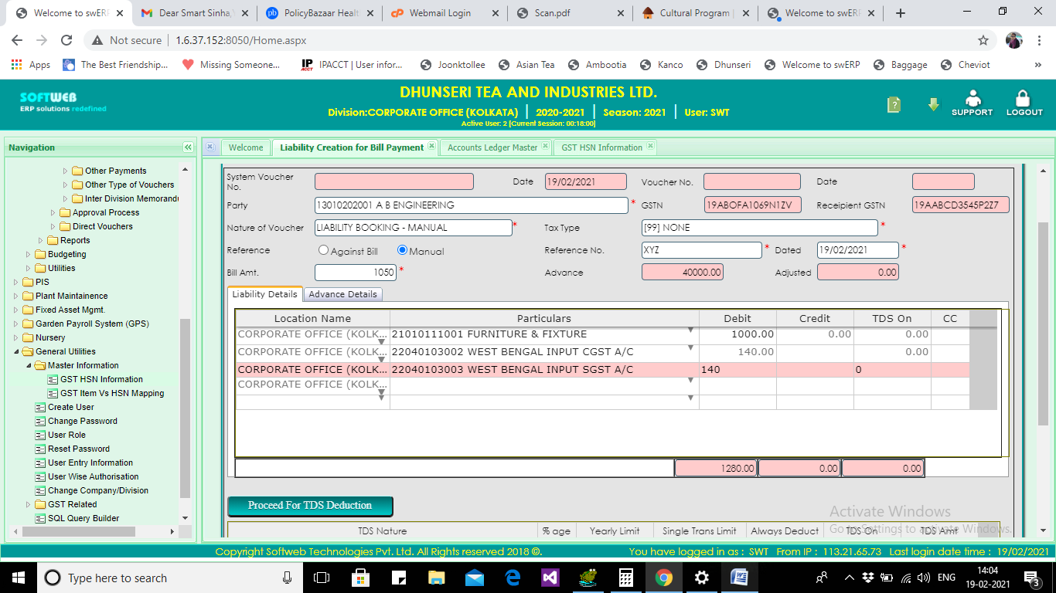

Task 4:

Add new Tab GST Details (features copied from GST PopUp task 1)

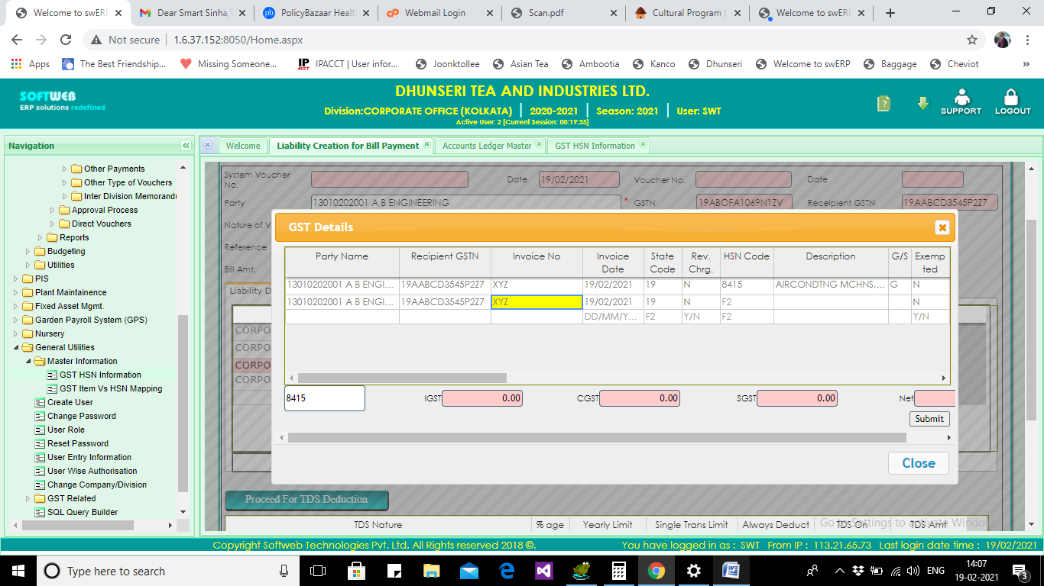

Task 5 :

Hide Columns from Party Name to Invoice Date

~~Add a new Column “Ledger” drop down~~

~~Condition~~

1. ~~From vw_acacledger~~
   1. ~~GST Applicable = ‘Y’~~
   2. ~~Group Type not in (‘TDS’,’Debtors’,’Creditors’,’Cash’,’Bank’,’GST’)~~

Task 6:

var PARTYSTATECODE = PARTYGSTNO.substring(0, 2);

var ReceipientSTATECODE = ReceipientGstn.substring(0, 2);

if (PARTYSTATECODE == ReceipientSTATECODE) {

chargenature = "'CGST','SGST'";

statecode = ReceipientSTATECODE;

}

else {

chargenature = "'IGST'";

statecode = ReceipientSTATECODE;

}

* State Code
* Gst Nature (CGST, SGST, IGST)
* INPU/ OUTPUT (From HSN)

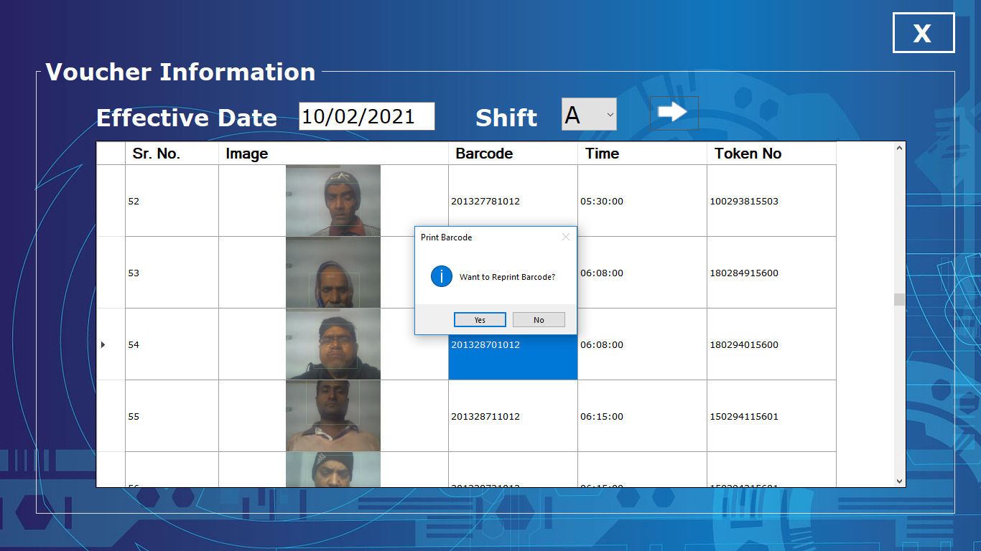

201328701012

180294015600

180294015600

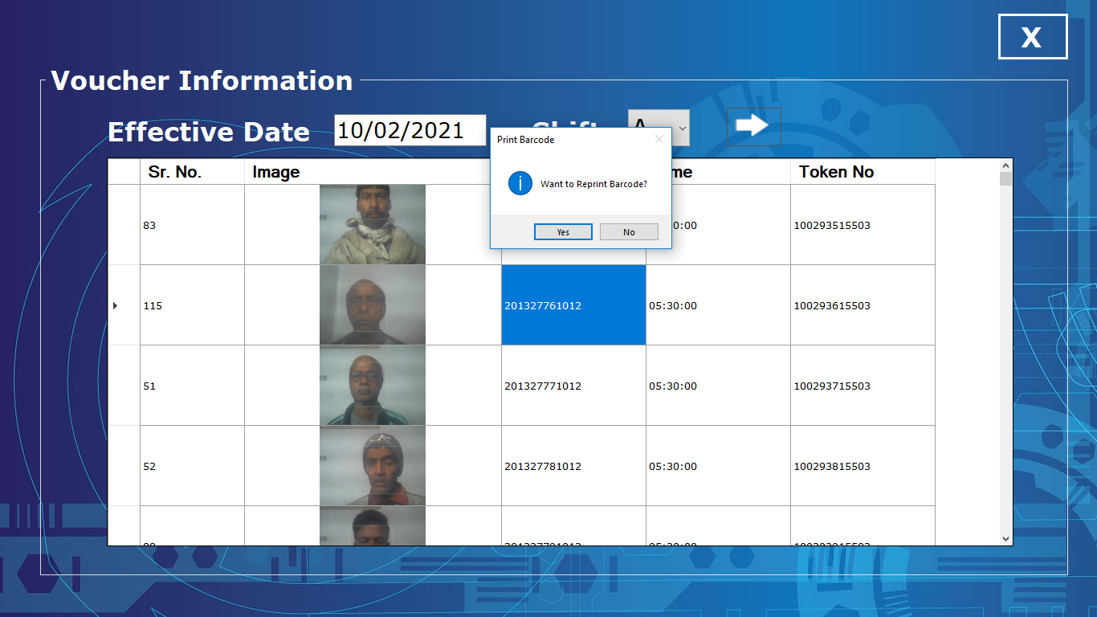

201328411012

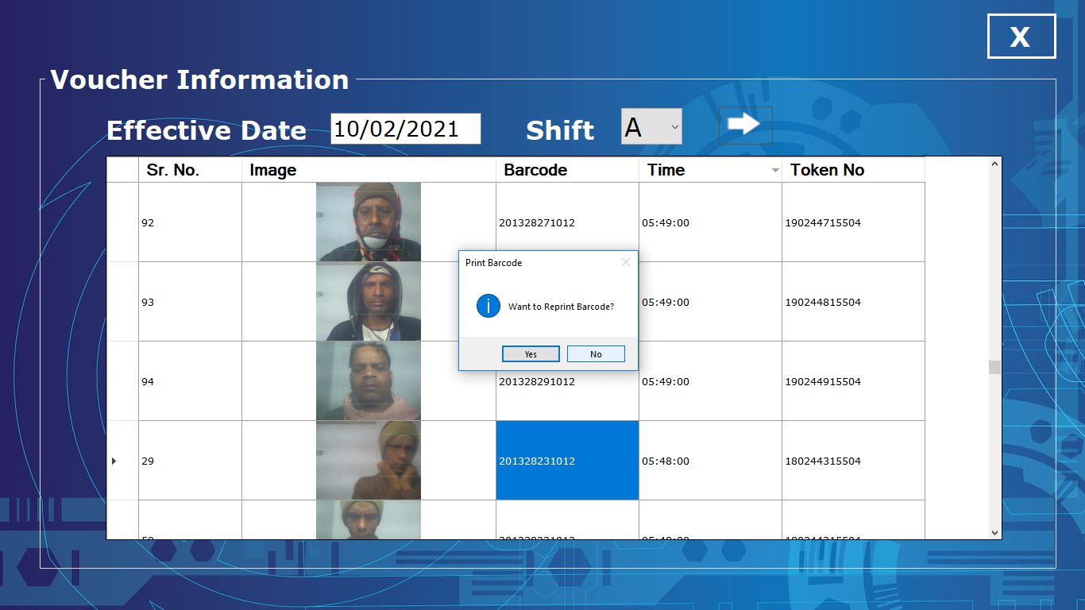

201328231012

180244315504